**Program 4**

Implement the basic and user status commands like: su, sudo, man, help, history, who, whoami, id, uname, uptime, free, tty, cal, date, hostname, reboot, clear.

**Solution**

1. **su** (Switch User):

- Allows a user to switch to another user account, if they have the required permissions.

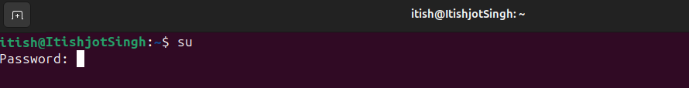

2. **sudo** (Superuser Do):

- Enables a permitted user to execute a command with the security privileges of another user (commonly the superuser or root).

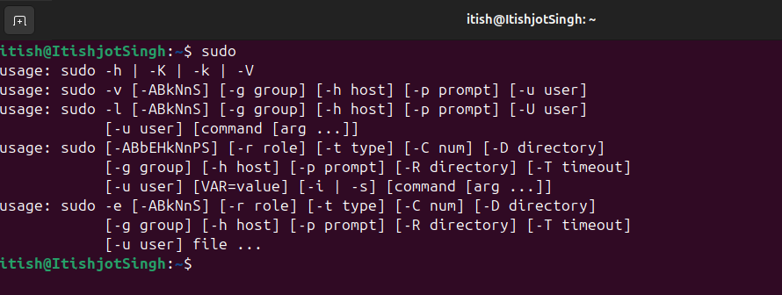

3. **man** (Manual Pages):

- Displays the manual pages for a specified command, providing detailed information on its usage, options, and examples.

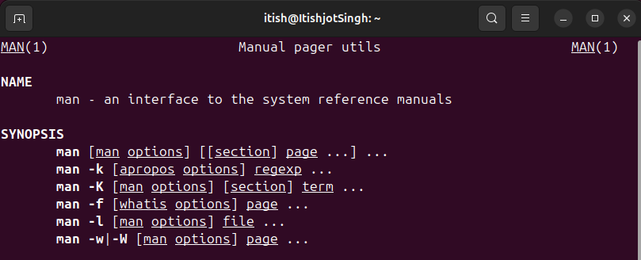

4. **help**:

- Displays help information about built-in shell commands, typically specific to the shell environment.

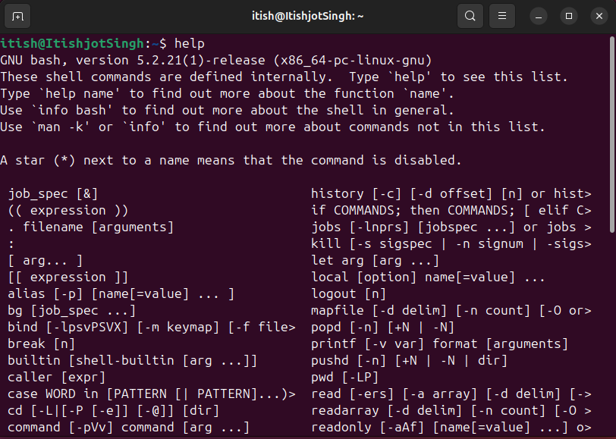

5. **history**:

- Displays a list of previously executed commands, allowing users to view and rerun commands from their history.

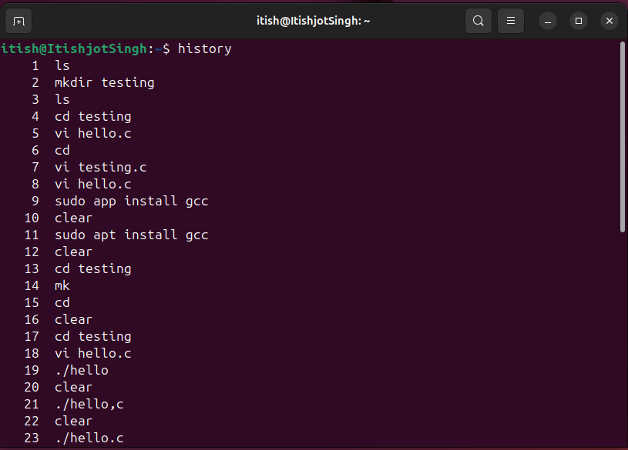

6. **who**:

- Displays information about users currently logged in, including their username, terminal, and login time.

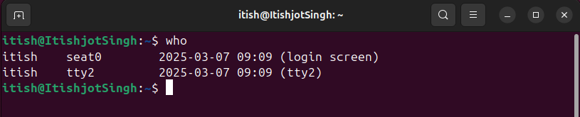

7. **whoami**:

- Outputs the username of the current effective user.

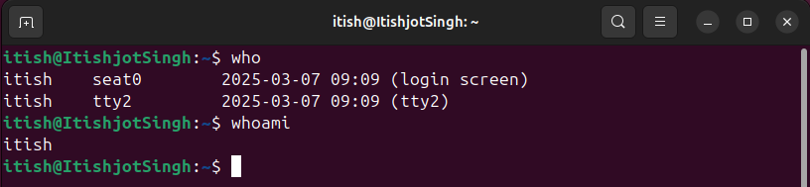

8. **id**:

- Displays user identity information, including user and group IDs.

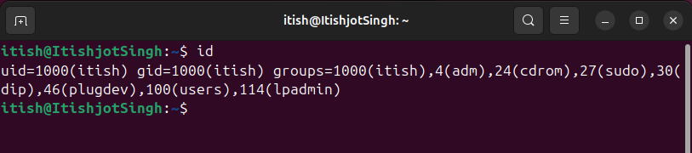

9. **uname**:

There are several sub commands of uname:

* **uname** : Displays Operating System name.

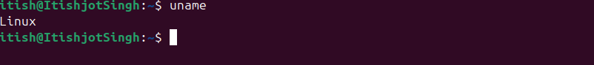

* **uname -a** :Provides basic system information such as system name, kernel version, and architecture.

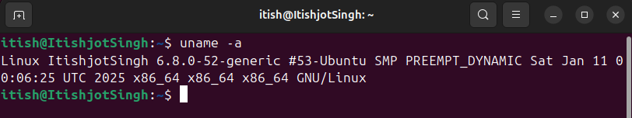

* **uname -s** : Displays Kernel Name.

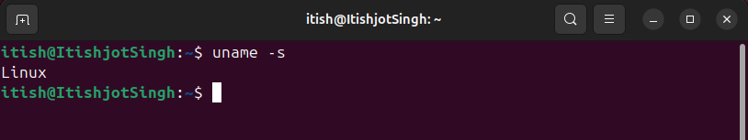

* **uname -v** : Displays version of the OS.

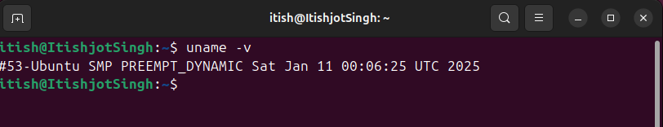

* **uname -r** : Displays Kernel version.

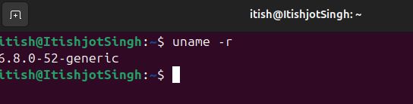

* **uname -p** : Displays the processor type or architecture of the system.

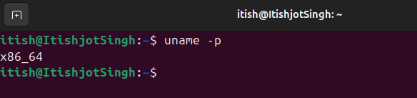

* **uname -o** : Displays the operating system name.

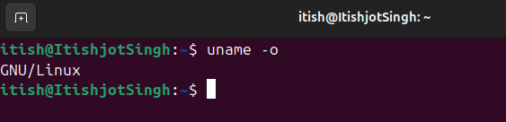

10. **uptime**:

There are several sub commands of uptime:

* **uptime** :Displays how long the system has been running, as well as load averages.

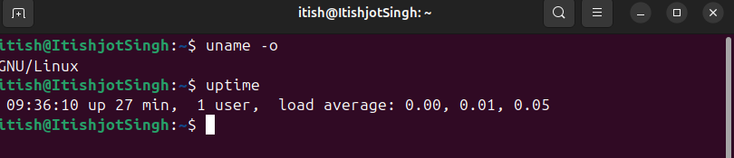

* **uptime -p** : Displays the duration since the system was last booted.

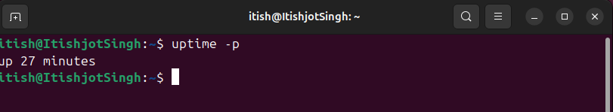

* **uptime -h** : Displays help box of uptime.

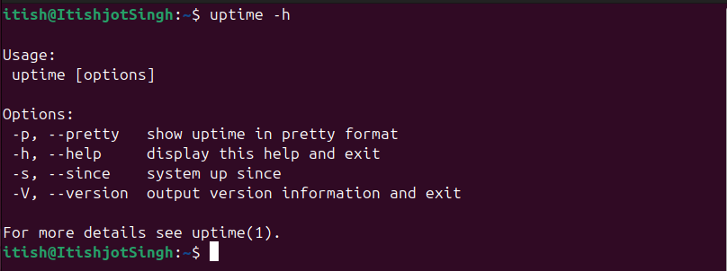

* **uptime -s** : Displays System up since.

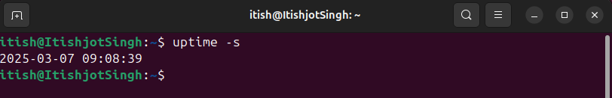

11. **free**:

- Shows the amount of free and used memory (RAM) in the system.

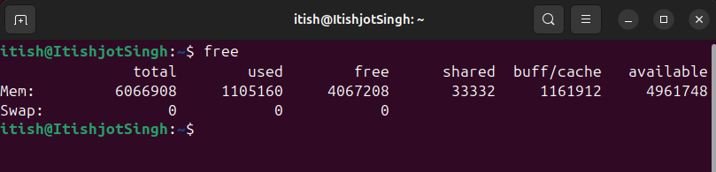

12. **tty**:

- Prints the file name of the terminal connected to standard input.

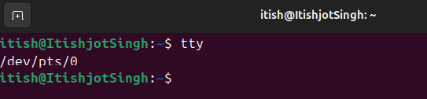

13. **cal** (Calendar):

There are several sub commands associated with cal command:

* **cal** :Displays a calendar for the current month or any specified month and year.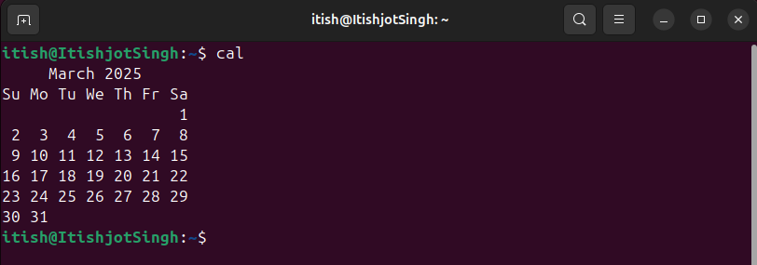
* **cal<month><year>** :Displays a calendar for the specified year of the specified month.

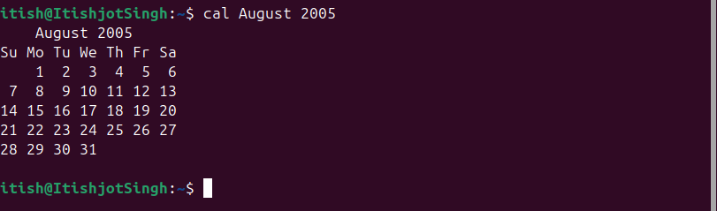

* **cal<year>** : Displays a calendar for the specified year.

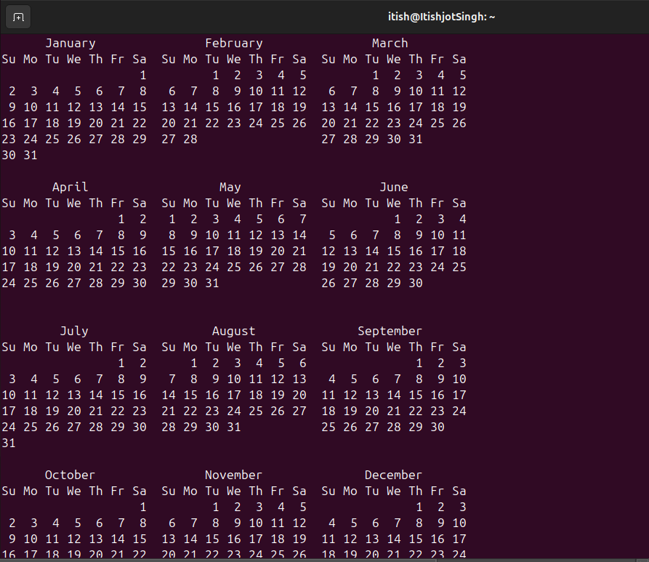

14. **date**:

There are several sub commands associated with date command.

* **date** :Prints the current date and time according to the system's clock settings.

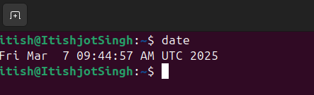

* **date “+%d/%m/%y”** : Prints current system date in format “day/month/year”.

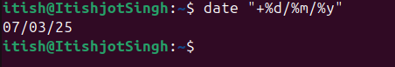

* **date “+%H : %M : %S”** : Prints current system time in format “Hour/Minute/Second”.

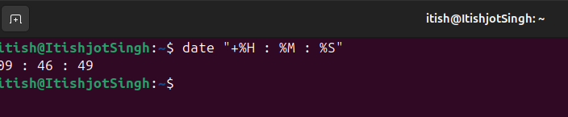

* **date “+%y”** : Prints current system year.

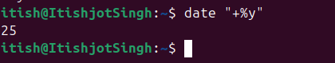

* **date “+%B”** : Prints current system month.

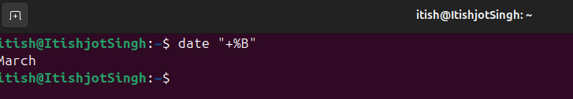

* **date “+%A”** : Prints current system Day.



* **date -d “Tomorrow”** : Prints date, time of Tomorrow.

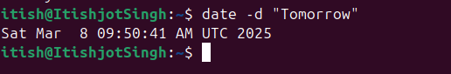

* **date -d “Yesterday”** : Prints date, time of Yesterday.

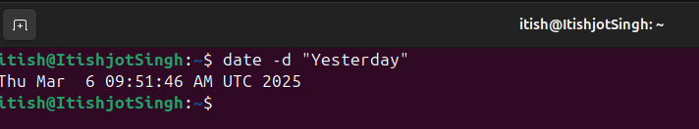

* **date -d “Month Ago”** : Pronts date, time of a month ago.

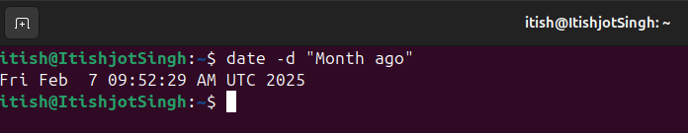

15. **hostname**:

- Displays the system's hostname (computer name).

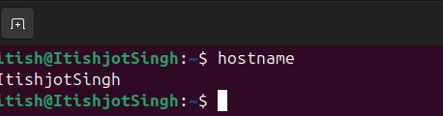

16. **reboot**:

- Initiates a system reboot, restarting the operating system.

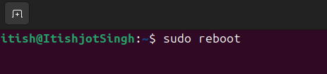

17. **clear**:

- Clears the terminal screen, providing a clean workspace for new commands and output.

